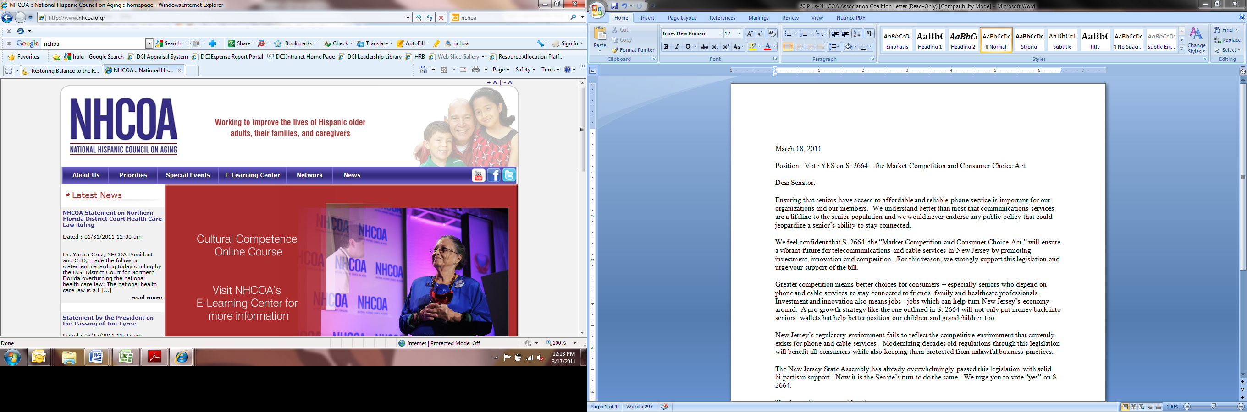[](http://www.ncba-aged.org/default.asp?contentID=1)

March 18, 2011

Position: Vote YES on S. 2664 – the Market Competition and Consumer Choice Act

Dear Senator:

Ensuring that seniors have access to affordable and reliable phone service is important for our organizations and our members. We understand better than most that communications services are a lifeline to the senior population and we would never endorse any public policy that could jeopardize a senior’s ability to stay connected.

We feel confident that S. 2664, the “Market Competition and Consumer Choice Act,” will ensure a vibrant future for telecommunications and cable services in New Jersey by promoting investment, innovation and competition. For this reason, we strongly support this legislation and urge your support of the bill.

Greater competition means better choices for consumers – especially seniors who depend on phone and cable services to stay connected to friends, family and healthcare professionals. Investment and innovation also means jobs - jobs which can help turn New Jersey’s economy around. A pro-growth strategy like the one outlined in S. 2664 will not only put money back into seniors’ wallets but help better position our children and grandchildren too.

New Jersey’s regulatory environment fails to reflect the competitive environment that currently exists for phone and cable services. Modernizing decades old regulations through this legislation will benefit all consumers while also keeping them protected from unlawful business practices.

The New Jersey State Assembly has already overwhelmingly passed this legislation with solid bi-partisan support. Now it is the Senate’s turn to do the same. We urge you to vote “yes” on S. 2664.

Thank you for your consideration.

Sincerely,

Jim Martin, Chairman

60 Plus Association

Karyne Jones, President & CEO

National Caucus & Center on Black Aged

Yanira Cruz, DrPH

President & CEO

National Hispanic Council on Aging